This process assumes you don’t have to paste any text from the GDS Core Tax Program into the STF 6053 or 6053A—see the Appendix if you need to. This process also assumes that you have a *smallpdf.com* account. I have attached the 3 forms for Gudell to go through the document to make sure it is correct. Apologies as you may find it remedial in some areas, but it’s best to over explain than to leave things out.

**PART 1**

**Prepare all the individual tax taking documents for uploading to your Town webpage**

1. Use the smallpdf tool to (1) merge the Final Notice of Tax Taking, (2) STF 6053, and (3) STF 6053A into a single file, compress that merged file, split it to remove blank pages, and rename it.

Steps:

1. Open smallpdf. The tools that you need are highlighted in Figure 1,
2. Click on Merge to bring up the **Select Files** box and use the drop down caret to select **From device** to open the file list.
3. While pressing the CTRL key, use the mouse to click on the 3 files for the person you are preparing, and press Open to bring them into smallpdf. See Figure 2.
4. Select **Finish**.

NOTE: Each time you select Finish, it brings up the **Done** box with the primary option of **Download**, but the file is not ready to download yet. The Done box also concatenates each step that was completed to your file name.

You will need to rename this before downloading ~~in step 1.8.~~

1. In the Done box, choose **Compress**, see Figure 3. The result of the compression is shown in Figure 4 .
2. Find the **Split** tool. If it is not visible, scroll down in the “**or continue in section**” area to find and select it.
3. Selecting **Split** brings up all the pages in the compressed file where you can now individually. delete blank pages by clicking on the trash can.
4. Select **Finish.**
5. . Rename the file before downloading. On the dotted line above the Download box, click on the smallpdf file name to bring up the rename box shown below where you can replace the file name. the smallpdf name will be something like:

*Gudell1X-merged-compressed-pages.pdf.*

Change this to *FY26_ParcelOwnerName.pdf*. Example *FY26_Gudell1.pdf or whatever system you have.*

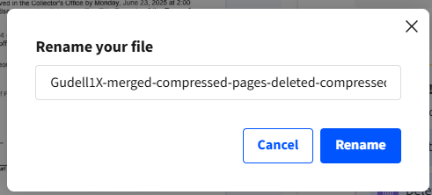

**1.10** Download the file.

**1.11** Repeat the process for all your other parcels. This takes about 2 minutes per set of files each once you get going.

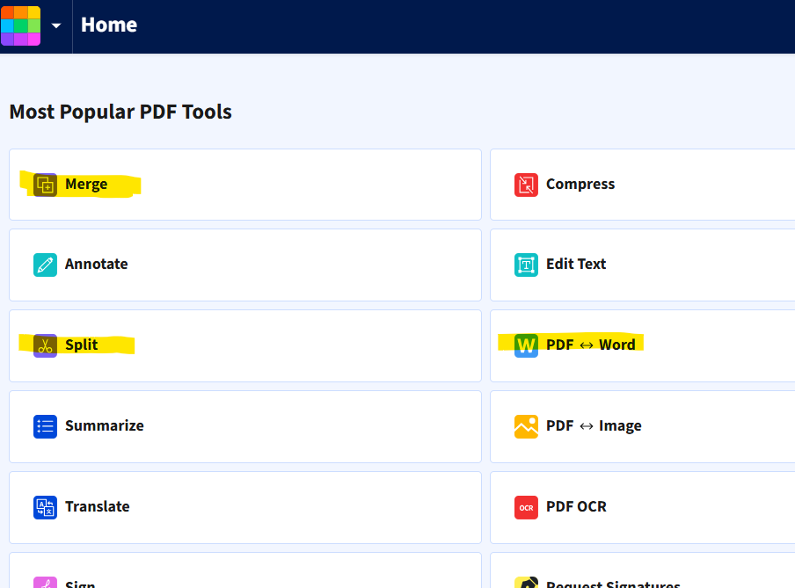

Figure 1

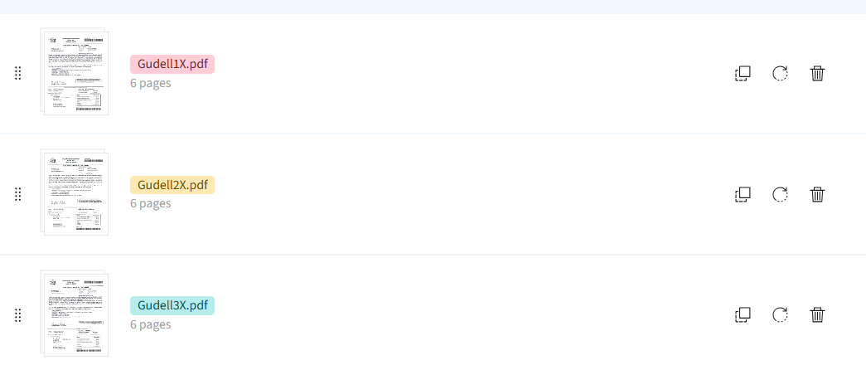

**Figure 2**

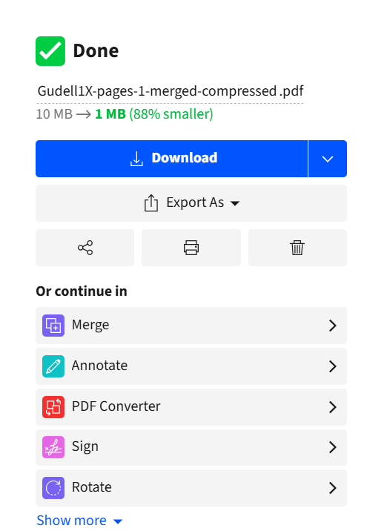

**Figure 4**

**re 4**



If you don’t see the Smart Tip box,

scroll down to the **Continue** section.

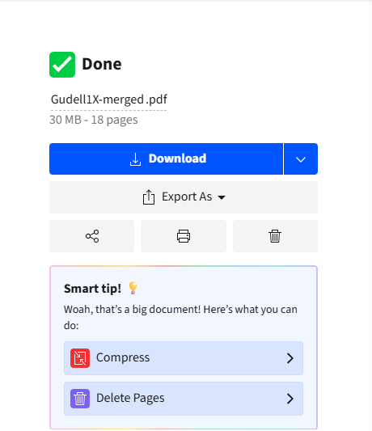

**Figure 3**

**Part 2**

**Uploading the files to the Tax Collector Webpage**

Steps:

1. Log into your Town page to create a new file category for your current year files
2. You will see sections in yellow titled **Tax Collector FY25 Files** and **Tax Collector FY24 Files.**
3. You will now need to create a new Files page forFY26
   1. In the upper left corner of the page click on the rocket icon to see the menu options
   2. Select **Manage Files** which brings up the **Manage File Categories** page.
   3. On the Manage Files Categories page select Create Category .
   4. Enter your new category name, **Tax Collector FY26 Files**
   5. Click on the Create New Category Button to finish creating the page.
4. Go to your Town home page to insert this new category.
   1. Go into the FY 25 section and select Insert New Section
   2. In the **Add New Section** box make the following choices:

Module: Files

Category: Tax Collector FY26 Files

Display: Table

* 1. Click Add Module to finish.
  2. In your new files section choose Upload Files.

Holding down the SHIFT key, use the mouse to select the first and last file to choose every file in between. All the files should now be highlighted and can be moved as a group. You can also hold down the CTRL key with the mouse if you want to select only particular files at this time.

**Part 3**

**Linking the parcel files to the Recorder Ad file,**

This must be done locally in Word and then the Recorder Ad file saved as a PDF.

Steps:

1. Open both your Town page and the Word version of the Recorder Ad side by side
2. On your Town page

2.1 Go to your **Tax Collector FY 26 Files** section to get the link for each parcel owner.

2.1 Select **Manage**, then **Manage This Category** to access the links

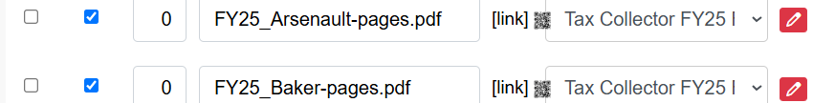

2.2 Place the cursor on [link] and right click.

2.3 From the resulting Drop down, select ***Copy Clean Link***

3. In the Word doc

3.1 Select the whole name of the person whose file you are working on

3.2 From the top menu bar select **Insert.**

3.3 From the submenu that comes up click **Links,** and then **Insert Link.**

3.4 The selected name should already be in the **Text to Display** box. Paste the copied link into the **Address** box.

3.5 After all the names are linked, Save the Word doc and then Export it as a PDF . You can also use Save As to create a PDF of the Recorder Ad.

3.6 Upload the Recorder Ad PDF file to the **Tax Collector FY26 Files** page.

**Part 4**

**Create a subpage for the Additional Pages box on your page.**

Steps

1. From the Tax Collector home/main page, click on the Create Sub Page
2. Enter the page name, in the In the **Nav Title** box, **FY 2026 PROPERTY TAX TAKING INFORMATION**, and select Create Page
3. Go to your **FY25** page and copy the text from there
4. Go to your FY26 page and , select Edit and paste in the text
5. Make your text updates in your FY26 page
6. Go to the Tax Collector FY 26 Files section and copy the link for the Recorder ad
7. Go back to the new subpage
8. Place the cursor on **Tax Taking Legal Ad** and Right click to bring up **Edit Link**
9. Enter the link that you copied for the FY26 Tax Taking Legal Ad
10. Click Save Changes.

**APENDIX**

This is only necessary if you have to cut and paste text from the GDS program into a state form.

Steps

1. Convert the STF 6053 to a Word doc.
2. Copy the text needed from the GDS output and paste it into the STF 6053 as text by clicking on the highlighted icon.
3. Export the updated STF 6053 as a PDF using the naming convention FY26_Gudel_6053_1 (the 1 is for for parcel 1)



1. Go back to Part 1.

