This process assumes you don’t have to cut and paste any text from the GDS Core Tax Program into the STF 6053 or 6053A. See the Appendix if you have to edit these files. This process also assumes that you have a [*smallpdf.com*](smallpdf.com) account. Currently the cost is $120, if paid yearly. You can also practice using a free account for 7 days, but you have enter a payment method. You can always cancel after the 7 days.

**PART 1**

**Prepare all the individual tax taking documents for uploading to your Town webpage**

1. Use the smallpdf tool to (1) merge the Final Notice of Tax Taking, (2) STF 6053, and (3) STF 6053A into a single file, compress that merged file, and rename it.

Steps:

1. Open smallpdf
2. Click on Merge to bring up the **Select Files** box and use the drop down caret to select **From device** to open the file list.
3. While pressing the CTRL key, use the mouse to click on the 3 files for the person you are preparing, and press Open to bring them into smallpdf. See Figure 2.
4. Select **Finish**.

NOTE: Each time you select Finish, it brings up the **Done** box with the primary option to **Download**, but the file is not ready to download yet. The Done box also concatenates each step that was completed to your file name.

You will need to rename this before downloading in step 1.8.

1. In the Done box, choose **Compress**, see Figure 3. The result of the compression is shown in Figure 4 where you now have the option to **Split** the compressed file.
2. Selecting **Split** brings up all the pages in the compressed file where you can now individually. delete them by clicking on the trash can to the right of the screen.
3. Select **Finish.**
4. . The file is now ready to download, but first rename the file. On the dotted line above the blue Download box, click on the smallpdf file name to being up the rename box shown below where you can replace the file name.

*Gudell1X-merged-compressed-pages-deleted-compressed.pdf,*

to *FY26_ParcelOwnerName.pdf*. Example *FY26_Gudell1.pdf*

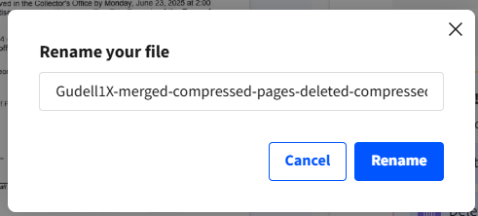

**1.9** Repeat the process for all your other parcels. This takes about 2 minutes set of files each once you get going.

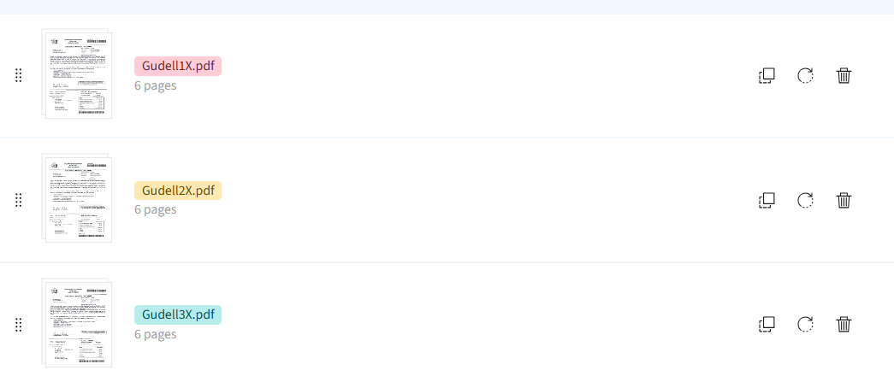

**Figure 2**

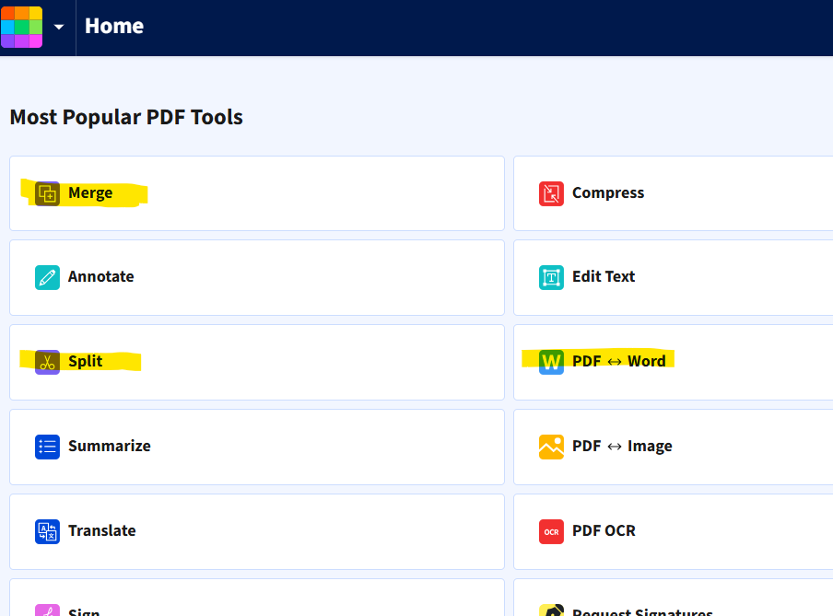

Figure 1

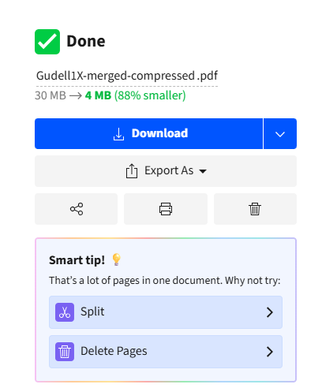

**Figure 4**

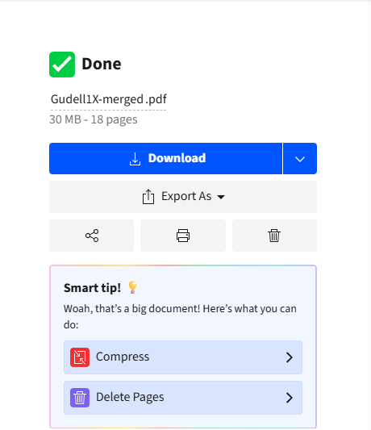

**Figure 3**

**Part 2**

**Uploading the files to the Tax Collector Webpage**

Steps:

1. Log into your Town page to create a new file category for your current year files
2. You will see sections in yellow titled Tax Collector FY25 Files and Tax Collector FY24 Files.
3. You will now need to create a new Files page for **FY26**
   1. In the upper left corner of the page click on the rocket icon to see the menu options
   2. Select **Manage Files**
   3. On the Manage Files page select the Create Category button.
   4. Enter your new category name and choose Hide under the Display options
   5. Click on the Create New Category Button to finish creating the page.
4. Go to your home page and select **Insert New Section** for this newly created category. I would suggest you place it just after Tax Collectors News.
   1. In the Add New Section box make the following choices:

Module: Files

Category: Tax Collector FY26 Files

Display: Table

* 1. Click Add Module to finish.
  2. On your new files page choose Upload Files.

Holding down the SHIFT key, select the first and last file to choose every file in between. All the files should now be highlighted and can be moved as a group. You can also hold down the CTRL key if you want to select only particular files at this time.

**Part 3 Linking the parcel files to the Recorder Ad file,**

This must be done locally in Word and then the Recorder Ad file saved as a PDF.

Steps:

1. Open both your Town page and the Word version of the Recorder Ad side by side
2. Go to your Tax Collector FY 26 section to get the link for each parcel owner.

2.1 Place the cursor on the file name and Right click.

2.2 From the resulting Drop down, select ***Copy Clean Link***

3. In the Word doc

3.1 Select the whole name of the person whose file you are working on

3.2 From the top menu bar select **Insert.**

3.3 From the submenu click **Links**

3.4 The selected name should already be in the **Text to Display** box. Paste the copied link into the **Address** box.

3.5 After all the names are linked, Save the Word doc and then Export it. You can also use Save As to create a PDF of the ad.

3.6 Upload the Recorder Ad PDF file to the **Tax Collector FY26 Files** page.

**Part 4**

**Create a subpage for FY 26 Information**

Steps

1. From the Tax Collector home/main page, click on the Create Sub Page
2. Enter the page name, FY26 . . .
3. Copy the text from your FY25 page into the text area of the new page
4. Make your text updates and Save.
5. Go to the **Tax Collector FY26 Files** section
6. Place the cursor on the file name, and Right click.
7. From the resulting drop down, select **Copy Clean Link**
8. Go back to the newly created sub page and highlight the **Tax Taking Legal Ad** and replace the FY25 link with the FY26 link.
9. Click Save Changes.

APENDIX

This is only necessary if you have to cut and paste text from the GDS program into a state form.

Steps

1. Convert the STF 6053 to a Word doc.
2. Copy the text needed from the GDS output and paste it into the STF 6053 as text, by clicking on the icon highlighted below.
3. Export the updated STF 6053 as a PDF using the naming convention FY26_Gudel_6053_1 (the 1 is for for parcel 1)



1. Go back to Part 1.

