- Log into your page
- Scroll down to the COA Files section which is in yellow because it is not visible on the page.
- Upload the new flyer to this section using the file naming convention COA_2026-month_News,jpg where month is the current month.
- Scroll to the Senior Center Monthly Flyer section.
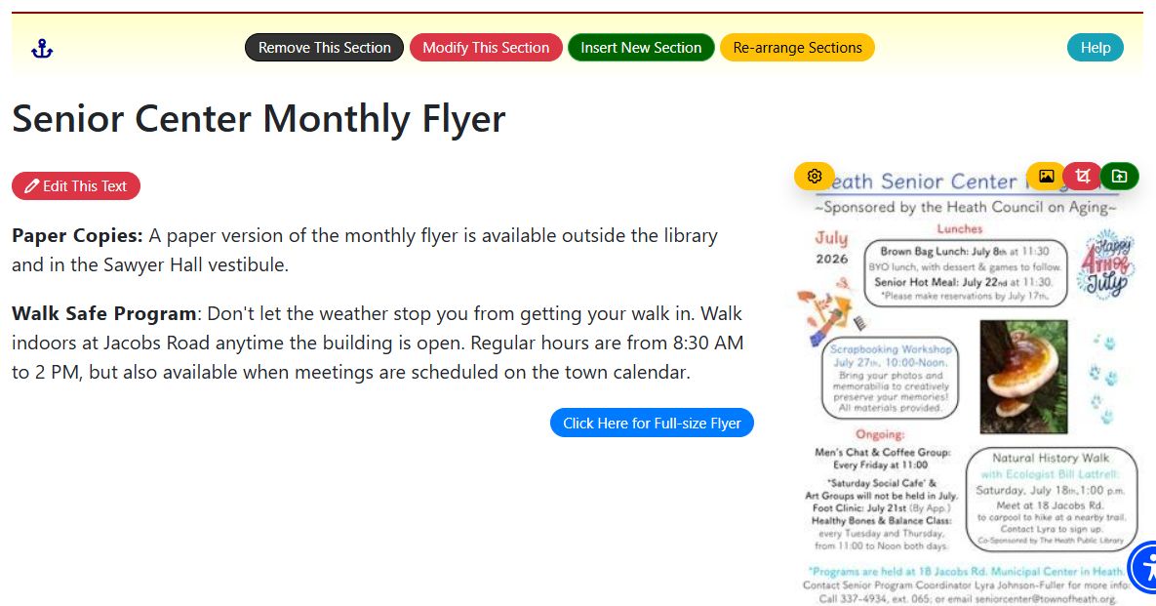
- Above the image of the flyer, click on the green upload icon to upload your flyer again. I don’t know why this is necessary, but using the yellow image button hasn’t worked for me.
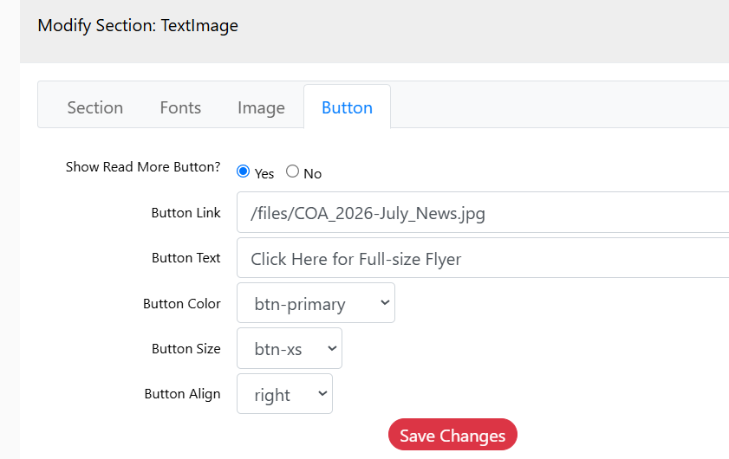
6. Next, to update the blue button to link to the new monthly flyer, click Modify This Section at the top of the section.
7. This brings up the TextImage screen.
Click on the Button tab and change the Button Link to the current month.
Save your changes, log out, and make sure the button link works.
If it doesn’t, these instructions need fixing so send me an email or call 978-987-6899.

