This process assumes you don’t have to paste any text from the GDS Core Tax Program into the STF 6053 or 6053A—see the Appendix if you need to. This process also assumes that you have a smallpdf.com account.
PART 1
Prepare all the individual tax taking documents for uploading to your Town webpage

- Use three smallpdf tools Merge, Compress, and Split to (1) Merge the Final Notice of Tax Taking, STF 6053, and STF 6053A into a single file, (2) Compress that merged file, (3) Split it to remove blank pages. Once these steps are done you need to rename the file.
Steps:
Open smallpdf.
- MERGE the PDFs
1.1 Click on Merge to bring up the Select Files box and use the drop down caret to select From device to open the file list.

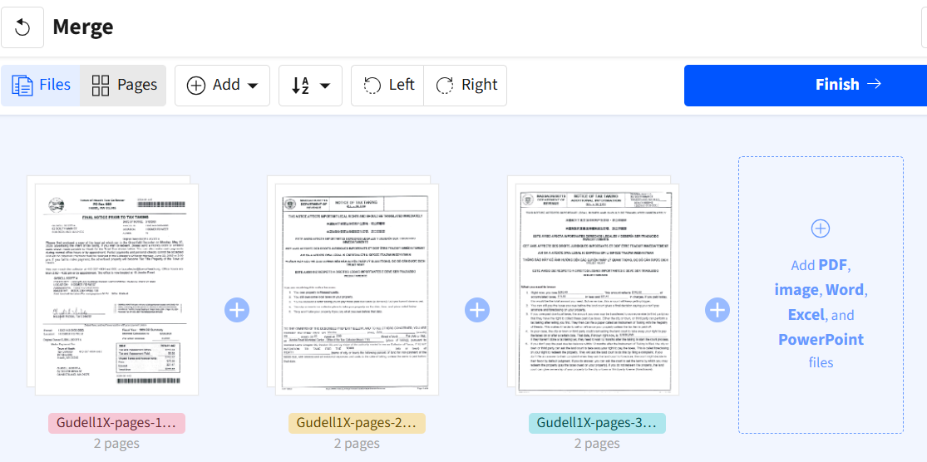
  - While pressing the CTRL key, use the mouse to click on the 3 files for the person you are preparing and press Open to bring them into the smallpdf Merge box shown below.

  - When the Merge completes the Finish button will appear in the upper right of the screen or below the Merge box depending on your screen width. Select Finish to go on to compress the file.

- COMPRESS the PDF
Selecting Finish in step 1.3 brings up a Done box (which appears after each action).
2.1 Choose Compress which is highlighted in the image below.
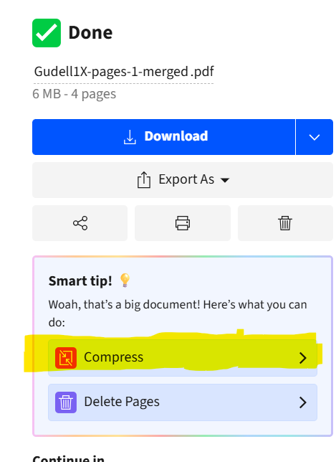
This brings up the options for the compression type .
  - On the Compress screen, accept the default choice of Basic and click on the blue Compress button.
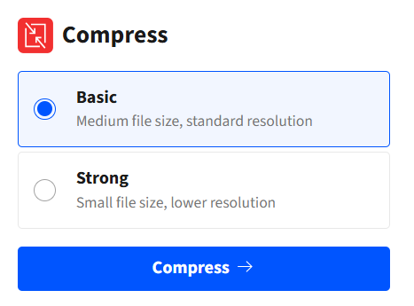

Note: The next Done box on the following page shows how much the file has been compressed.

- SPLIT the PDF
The next step is to use the Split tool to remove blank pages if you have any.
3.1 The Split tool is not visible, so you will need to select the Show more down caret ( which is at the bottom of the image to the left)
3.2 After selecting the show more down caret, scroll down until you find Split.
3.2 Selecting Split brings up all the pages in the file where you can now individually delete blank pages by clicking on the trash can.
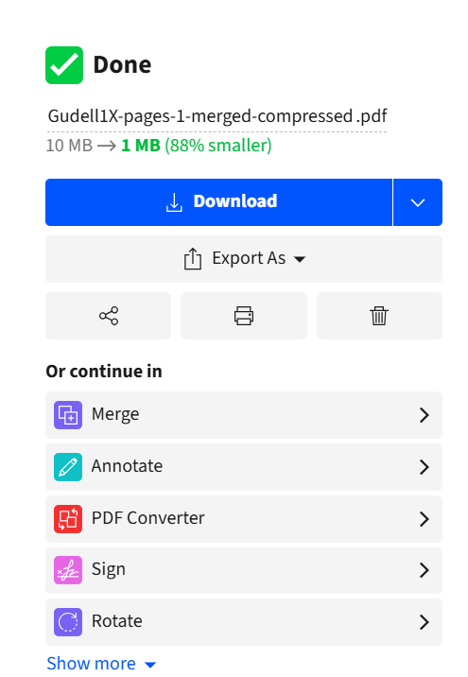
- RENAME THE FILE

re 4
The dotted line on the image to the left shows the smallpdf file name, in the example it is,
Gudell1X-pages-1-merged-compressed-pages.pdf.

4.1 Click anywhere in that file name to bring up the Rename your file box

  - Change this name to FY26_ParcelOwnerName.pdf.
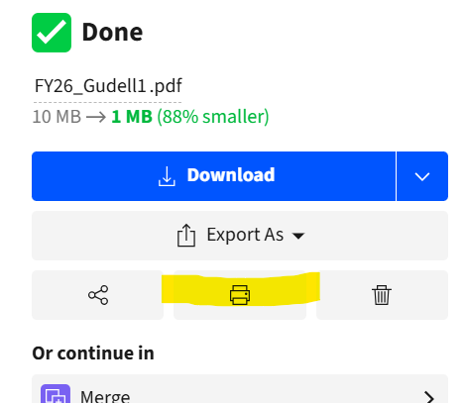
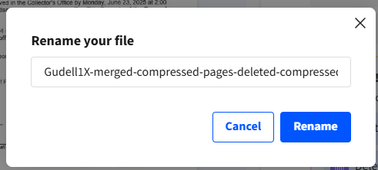
Example: FY26_Gudell1.pdf or whatever system you have
- SAVE THE FILE
Right click on the printer icon highlighted in the image to the right which brings up a list that includes the Save as . . . option where you can save the file in the Tax Collector FY 26 folder.
- Repeat this process for all your other parcels. This takes about 1 to 2 minutes per set of parcels each, once you get going.

PART 2
Uploading the files to the Tax Collector Webpage
Steps:
- Log into your Town page to create a new file category for your current year files
- Scroll down to see the sections in yellow for your previous years titled Tax Collector FY25 Files and Tax Collector FY24 Files.

- You will now need to create a new Files page for Tax Collector FY26 Files
  - In the upper left corner of the page click on the rocket icon to see the menu options.
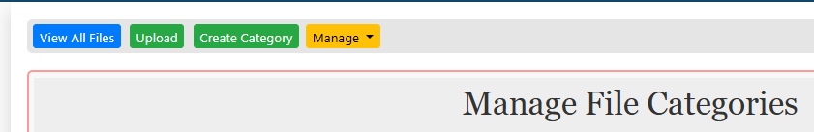
  - Under Modules, select Manage Files which brings up the Manage File Categories menu bar shown in the image below.

  - On the Manage Files Categories menu bar select Create Category .
  - This brings up the Add New Category box where you can name the category. Enter your new category Name, Tax Collector FY26 Files and leave the Sort By and Display fields as shown.
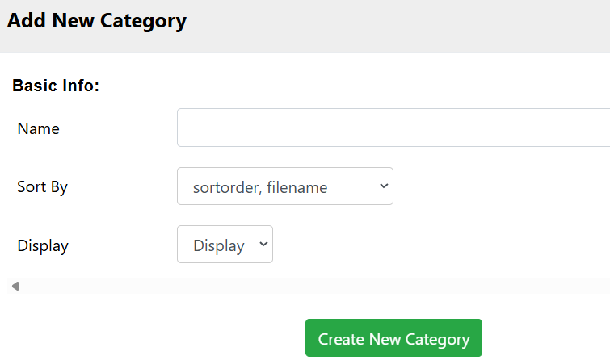
  - Click on the Create New Category Button to finish the process of creating the category.

- Insert this new Files category on your Town home page
  - On your home page scroll down to the section for the previous year, Tax Collector FY25 Files
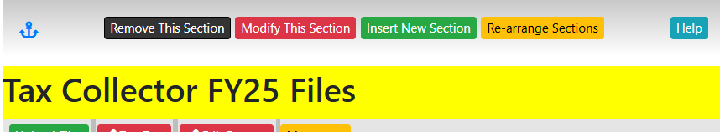
  - On the top menu bar select Insert New Section . This will bring up the Add New Section box.
  - In the Add New Section box, in the Module field, use the Pick a Module drop down to select Files. In the Category drop down scroll down to find your newly created section. Tax Collector FY26 Files
Leave the Display and Style fields as they are
Click Add Module
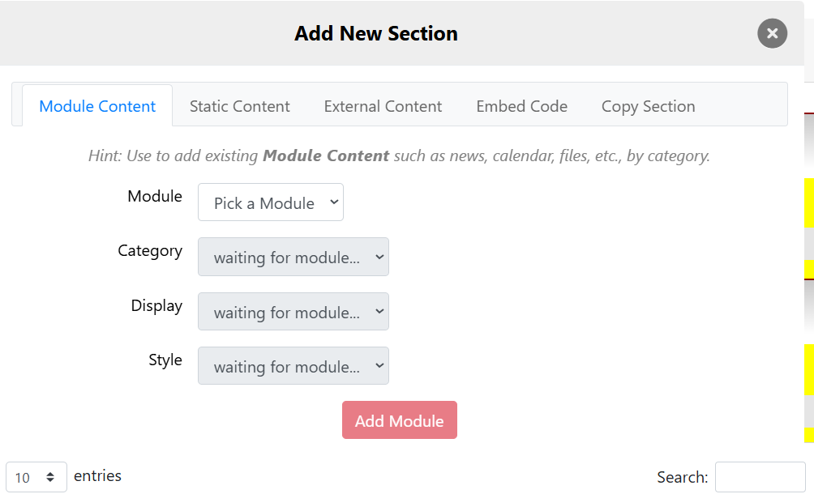

- Upload all the files for each homeowner’s parcel into your new files section

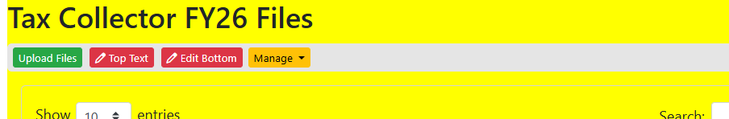
  - The new section for Tax Collector FY26 Files will now be visible

  - In this new section choose Upload Files from the menu bar and upload all the files for each homeowner’s parcel. I believe this can be done by selecting them all and dragging them into the Select Files box.

  - Stay on this page as you will need to copy the hyperlinks for each parcel in PART 3

PART 3
Adding hyperlinks for each parcel in the Recorder Ad DOCX file.
The links must be done on your local PC in MS Word.
Steps:
- Open your Word file for the Recorder Ad and have it beside the Tax Taking FY26 Files section. You will want to go back and forth between the files and the Recorder Ad.
- On your Town main page,
  - scroll down until you get the Tax Collector FY 26 Files
  - Place the cursor on the file for the parcel that you want to link to the ad. Do not double click. The file name should become underlined. Now right click on the file and select Copy Clean Link or Copy Link whichever comes up.
3. Go to the Word doc
3.1 Select the whole name of the person whose file you are working on
3.2 From the top menu bar select Insert.
3.3 From the submenu that comes up click Links, and then Insert Link.
3.4 The selected name should already be in the Text to Display box. Paste the copied link into the Address box.
3.5 Save your file periodically.
3.6 After all the names are linked, save the Word doc, and then save it as a PDF or Export it as a PDF .
3.6 Upload the Recorder Ad PDF file to the Tax Collector FY26 Files page in the same way as in Part 2, Step 5.

Part 4
Modify the FY25 Tax Taking 2025 Property Information page for the new tax year.
In this section you will (1) update the FY25 page with FY26 information, update the link from the FY25 Recorder Ad to the FY26 Recorder Ad, and (3) rename the link from FY 2025 TAX TAKING PROPERTY INFORMATION to FY 2026 TAX TAKING PROPERTY INFORMATION
- Update the FY25 page with FY26 information
Rather than create a new page for every tax year, you may choose to simply update the existing page for the current year, partially shown below, and rename it for the current year.

The link, FY 2025 TAX TAKING PROPERTY INFORMATION, found on your home screen will bring up the page, Tax Taking FY25, which contains
- the text for the previous year and (2) the link to that year’s Recorder ad.
  - Update the text in the page to reflect the current year.

Tax Taking FY25
CHANGES TO THE COLLECTION OF DELINQUENT TAXES EFFECTIVE JULY 1, 2025
The Heath Selectboard has voted the following changes to the collection of delinquent taxes effective July 1, 2025:
The Demand fee will increase from $10.00 to $25.00 on all delinquent taxes. Please remember that taxes are due in the Collector's Office on the due date, postmarks are not considered. So mail your payments early to avoid demand fees on small interest charges, or pay on line where any additional interest is calculated.
Liens on delinquent Real Estate will be placed four months following the fourth quarter due date. This means that liens will generally be placed in September in the same year as the May 1st due date. You will have less time and receive fewer notices than in the past. Please note that it is less expensive to pay the tax balance before the property has been advertised for Tax Title.
TAX TITLE PAYMENT INFORMATION
Tax Title Fiscal Year 2025
TO FIND YOUR INFORMATION
Click on TAX TAKING LEGAL AD to view the Notice of Tax Taking that was published in the Greenfield Recorder on September 5, 2025.
Click on individual names in the legal ad to view the Final Notice Letter with the total due and payment options, and the STF 6053 & STF 6053A for that parcel.
. . .

- Get the link for the current Recorder Ad.
  - Scroll down to the Files section for the current/latest tax year, Tax Collector FY26 Files.
  - Put the cursor on the Recorder Ad and right click to bring up the option box.
  - Select Copy Clean Link to copy the link to the new Recorder Ad to the clipboard.

- Update the link for the Recorder Ad
  - While in the new Tax Taking FY26 page, click the red Edit button in the upper left of the page
  - Place the cursor in TAX TAKING LEGAL AD and Right click.
  - From the resulting drop down, select Edit Link to bring up the Link box shown below.
  - Under Protocol select https:// from the drop down
  - In the URL box, paste the link for the new Ad that you just copied
  - The Display Tex box should already be filled in.
  - Click on the Target tab and from the target drop down, select New Window (_blank).
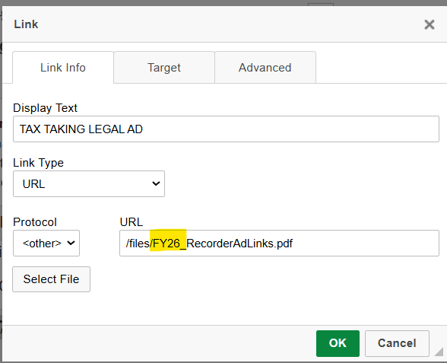
  - Click on OK.

This completes all the tasks that need to be done. Note: There are some short cuts you may discover as you become more familiar with the Town web page functionality so trust yourself to try other methods.

APENDIX A
This is only necessary if you have to cut and paste text from the GDS program into a state form.
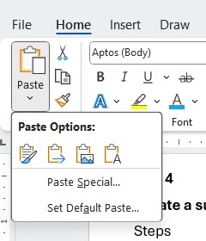
Steps
- Convert the STF 6053 to a Word doc.
- Copy the text needed from the GDS output and paste it into the STF 6053 as text by clicking on the highlighted icon.
- Save the updated STF 6053 as a PDF using the naming convention FY26_Gudel_6053_1 (the 1 is for for parcel 1)
- Export the updated STF 6053 as a PDF using the naming convention above.
- Go back to Part 1.

