But Is It Art: A Retrospective of Del Viarengo’s Creations

The Community Hall on Heath Common will be filled with the artistic creations of Del Viarengo from May 20 through May 27. Stop by and see an inspiring array of Del's paintings, drawings, pastels, and constructions.

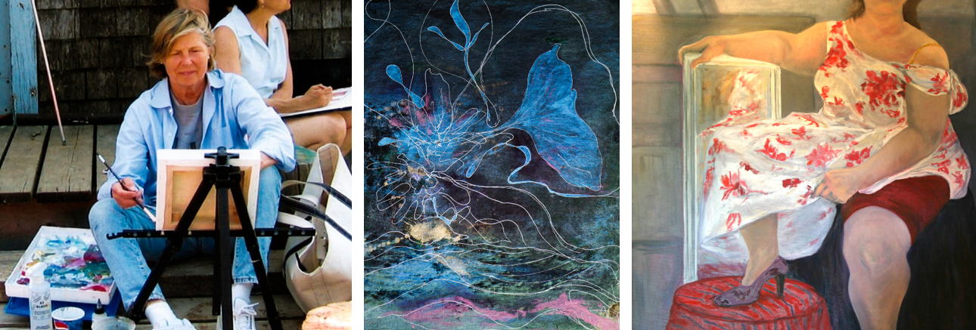

WHAT: But Is It Art: A Retrospective of Del Viarengo’s Creations

WHERE: Community Hall, Heath Town Common, Heath, MA 01346

WHEN: Saturday, May 20, 2023 through Saturday, May 27, 2023

EXHIBITION HOURS: Saturday, May 20 through Saturday, May 27 from 2 to 4 p.m.; Opening Reception: Sunday, May 21 from 2 to 4 p.m.

This art exhibition is a celebration of the life and boundless creativity of Heath artist Del Viarengo (1932-2022). Showcasing approximately 80 works, including paintings, reliefs, drawings and sculptures, the posthumous retrospective is a comprehensive survey of the artist’s prolific output over the course of her career.

The exhibit will fill the entire Heath Community Hall. Admission is free.

But Is It Art: A Retrospective of Del Viarengo’s Work is organized and curated by the Heath Arts Exhibition Committee, with assistance from the artist’s family. For information, contact Jean Gran at jean@jeangran.com or 413-824-2939

