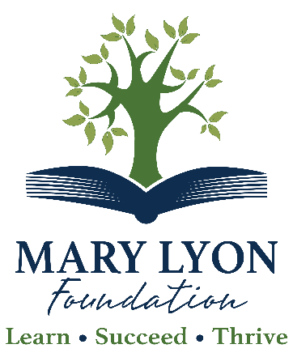

Board of Trustees

Laurie Benoit
Chair

Peter Stevens
Vice Chair

Karen Blom
Treasurer

Ellen Miller
Secretary

Traci Ayer

John Cornman

Karen Fairbrother

Bev LaBelle

Jana Standish

Arthur De Bow

Staff

Kristen Tillona Baker
Executive Director

Cassy Coeur
Business Manager

Dee Dee Pielock
Executive Assistant

Mary Lyon Foundation Annual Report
October 1, 2021 - September 30, 2022

Fiscal Year 2022 (FY22) was a record year for the Mary Lyon Foundation. We exceeded our expectations in the silent phase of our Campaign for Student Success and raised $2,082,635.69 toward our goal of $5,000,000 over five years. Total campaign revenue since the Campaign began on October 1, 2020, is $2,827,668.

The Campaign for Student Success is a bold initiative that allows us to invest in the most pressing needs facing our students, families, and educators.

The Mary Lyon Foundation is working tirelessly to ensure that all students come to school ready to learn, succeed academically, socially, and emotionally and thrive in the wider world. Our goal is to provide families with access to the services needed to foster a healthy and stable learning environment at home and school. We strive to ensure that Mohawk Trail and Hawlemont School District educators have the tools and resources they need to give our students the best possible education possible.

The Foundation’s programming and services have expanded substantially in FY22 to meet the ongoing needs of our community.

Some program highlights are below:

- We expanded our scholarship offerings to graduating students living in the Mohawk Trail Regional School District.
- Our food scarcity program has grown, and the Foundation currently delivers groceries to 140 People every other Tuesday. This program has doubled since its inception in July of 2021.
- We supported all educator assistance requests that promoted reimagination and innovation in the classroom.
- We provided funding for students to help with driver’s education, CPR and first aid certification, serve-safe certificates, computers for college, and much more.
- Our Adopt a Child/Family program provided 73 children with gifts during the holidays, thanks to our partnership with Greenfield Savings Bank.
- Thanks to our partnership with the United Way and the Warm the Children Program, two hundred children in our community received funds so parents could buy winter clothing and boots.
- Due to the generosity of our community and the DAR, we gave warm winter hats, mittens, and scarves to the six schools in the school district and Valley Play School.
- Through our Walmart Gift Card Program, 158 gift cards were distributed to parents so they could purchase school supplies and other items to prepare their children for school.
- We partnered with the Salvation Army to help families with groceries, clothing, and utility bills through their Hometown Endowment Program.
- We funded scholarships to families so their children could attend summer and vacation camps and programs while parents worked.
- We provided parents of newborn babies with helpful supplies in collaboration with the DAR and the Good Neighbors knitting groups.
- We organized the West County People Who Support People Consortium in partnership with FRCOG and Community Action. This group of seventy service providers meets quarterly to discuss how we can connect our community to the programs and services available to our families and students.
- In partnership with MTRSD and Foxtown Diner, we supported a district-wide celebration of learning and gave graphic novels and dinner to children and families throughout the district.
- We partnered with The Optician to provide glasses for many children within the community.
- We provided emergency relief to families who needed help with their utility bills.
- We initiated a Period Poverty Program in the district, giving young women sanitary products.
- We provided funding for the Preschool Assessment of Stereopsis with a smile, a program that measures children’s and nonreaders’ depth perception.
- We provided funding for the senior class’s Franklin County Fair Fundraiser. The senior class raises funds to pay for prom and other school-wide events throughout the year.
- We funded four seniors so they could fulfill their capstone projects.
- We partnered with MTRSD and helped fund a teacher appreciation ice cream social.

Campaign Highlights:

- The Mary Lyon Foundation endowed the Mohawk Trail Sustainability Endowment through an anonymous donor.
- A campaign pledge funded the Paulyne and Harper Gerry Student Assistance Endowment.
- A campaign pledge funded Guardian Angel Endowment.
- We provided funding to build a new Career and College Readiness Center at the high school.
- We provided grant funding to multiple organizations to better serve the surrounding community.
- We funded the before- and after-school programs at Hawlemont Regional School through an anonymous donation.
- Through the generosity of Marion and Gordon Taylor, we created the Marion J. and Gordon E. Taylor Endowment, which will provide funding in perpetuity in areas of greatest need.
- In partnership with Gloriosa, we hosted our first campaign event and raised $40,000 for the Marion J. and Gordon E. Taylor Endowment.

Through our campaign fundraising, the Mary Lyon Foundation has significantly increased our program and service delivery in FY22. As a result, we hired a part-time Program Coordinator to help manage, maintain, and expand our programming.
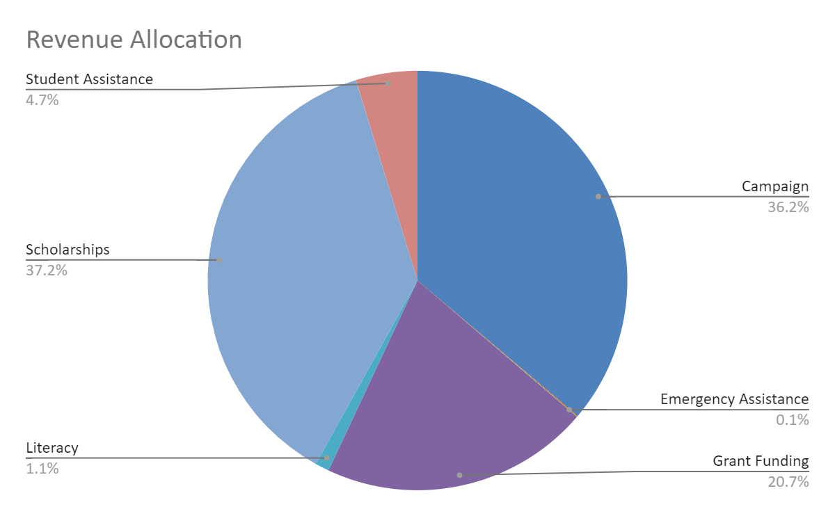
In FY22, many students and families faced extraordinary challenges. With the support of our constituents and community partners, the Mary Lyon Foundation expanded existing programs. It developed new initiatives to help meet the needs of our community across the district.

Through our Campaign for Student Success, we will continue to fundraise for the next few years to expand existing programs and underwrite our operating endowment. The Campaign will secure the Foundation’s future and ensure that we will provide funding so that all students come to school ready to learn, succeed academically, socially, and emotionally and thrive in the wider world.

Revenue and Expenditure Descriptions:

Special Projects: Donations the Foundation receives are earmarked for other programs, such as
- the Buckland Recreation Department’s Pool Project
- Career and College Counseling Center

Scholarships: Scholarship funding received and established by the Mary Lyon Foundation paid out to Mohawk Trail Students.

Unrestricted Endowment: Income from unrestricted donations is given to the Mary Lyon Foundation for use where needed most.

Educator Assistance: Funding for educators in the Mohawk Trail and Hawlemont School Districts to support reimagination and innovation in the classroom.

Emergency Assistance: This category supports the Guardian Angel, Paulyne and Harper Gerry Student Assistant Funds. These funds support the family and children of the district by providing assistance for groceries, and clothing, avoiding shut off of utilities, etc.

Literacy: Funding to support literacy in children from birth through high school.

Operations: Annual fundraising to support the Mary Lyon Foundation’s daily operations.

Restricted Endowments: Income from restricted endowments underwrite the Mary Lyon Foundation’s programs, services, and scholarships in perpetuity. (e.g.) Student Assistance, Emergency Assistance, Literacy, and Educator Assistance.

Campaign Fundraising: Unrestricted funding for immediate use where it is needed most.

Respectfully submitted,

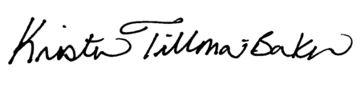

Kristen Tillona Baker
Executive Director

