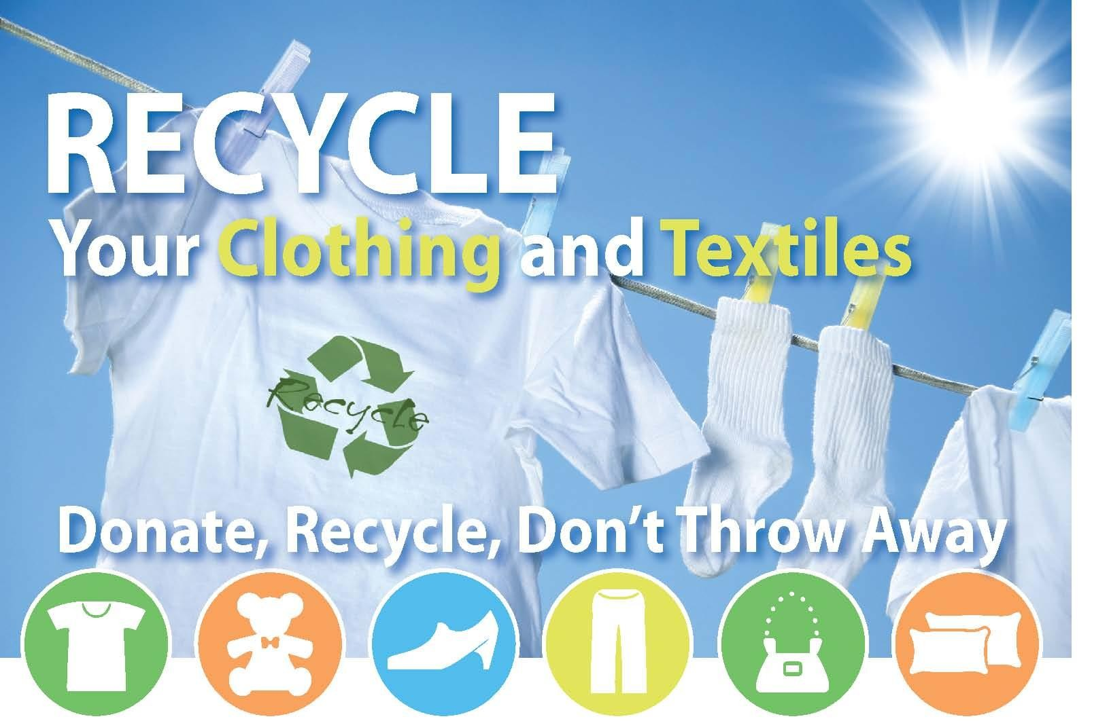
A Salvation Army drop box for textile recycling
is located at your town’s
transfer station.

Broken zippers? Missing buttons? Stained?
As long as it’s dry and not moldy … it’s acceptable!

Bring it ALL to the Salvation Army drop box at your town’s transfer station!

- Pants
- Shorts
- Shirts
- Pajamas
- T-shirts
- Jerseys
- Sweatshirts/pants
- Sweaters
- Jeans
- Dresses
- Skirts
- Coats
- Jackets
- Suits
- Scarves
• Undergarments/Bras
- Shoes (singles too!)
- Flip Flops
- Slippers
- Belts
- Ties
- Backpacks, book bags
- Hats
- Socks (singles too!)
- Purses
- Comforters
- Sheets
- Blankets
- Pillow cases
- Curtains/Draperies
- Table linens
- Stuffed animals

UNACCEPTABLE:
Carpets, rugs, oily rags, mattresses, bric-à-brac, wet, or mildewed items.

Info: Franklin County Solid Waste District, 413-772-2438. MA Relay for hearing impaired: 711 or 800-439-2370 (TTY/TDD). Info@franklincountywastedistrict.org

